**6)**

a)

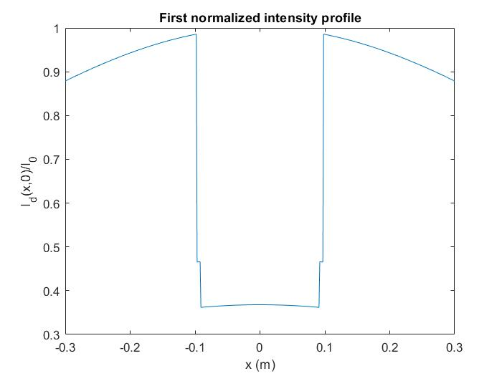

Figure 1.1

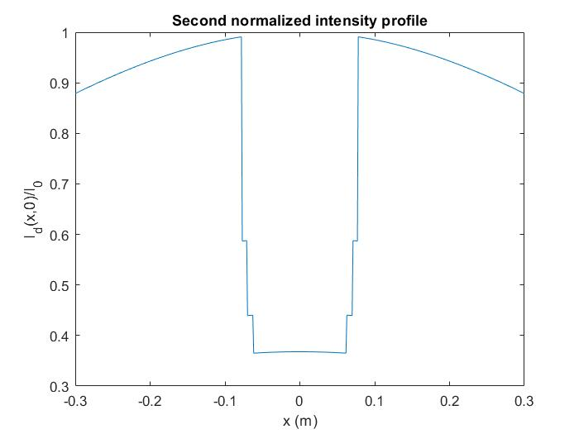

Figure 1.2

b) Geometrically speaking, in the first profile, light beam must travel with a larger angle compared to the second profile for no collision with the object. This can also be verified from the plots, since in the second profile, normalized intensity approaches to 1 before the first profile. Other than the middle part, the plots are essentially the same, since after a certain point there is no collision in both profiles.

**APPENDIX**

**MATLAB code for Q6:**

%% HW 2

x_val = linspace(-0.3,0.3,512);

%% empty intensities

intensity_1 = [];

intensity_2 = [];

%% generate intensities

% by the way, code runs poorly because i had some problems while

% vectorizing it, so instead of debugging it i just used two for loops, it

% takes max 1 mins to compile.

for i = 1:size(x_val,2)

fun1 = @(z) rectangularPulse((z-0.55)/0.1)*rectangularPulse(z*x_val(i)/((2*z/sqrt(3))-(1/sqrt(3))));

fun2 = @(z) rectangularPulse((z-0.85)/0.1)*rectangularPulse(z*x_val(i)/((2*z/sqrt(3))-(16/(10*sqrt(3)))));

intensity_1(end+1) = ((1/(1+(x_val(i))^2))^(3/2)).*exp((-10/((1/(1+(x_val(i))^2))^(1/2)))*integral(fun1,0,1));

intensity_2(end+1) = ((1/(1+(x_val(i))^2))^(3/2)).*exp((-10/((1/(1+(x_val(i))^2))^(1/2)))*integral(fun2,0,1));

end

%% figures

figure;

plot(x_val, intensity_1);

xlabel("x (m)");

ylabel("I_d(x,0)/I_0");

title("First normalized intensity profile");

figure;

plot(x_val, intensity_2);

xlabel("x (m)");

ylabel("I_d(x,0)/I_0");

title("Second normalized intensity profile");